DIS-INDO-Biak Island-Figure

**Korwar ancestor figure 26 in. tall, sculpted in wood and showing evident patina of age. This korwar comes from a large ethnographic collection acquired by the Bouck Estate, New York City, in 2014. This figure was excavated from Biak Cave on Biak island prior to 1942 when the Japanese invaded the island and desecrated the interior. The cave was finally burned with gasoline by Allied Forces in 1944. Because this figure shows great patina it must date from the late 19th or early 20th century as a ceremonial object. The last skillful korwar carvers in Biak kept a large collection of korwar and other artifacts until Christian missionaries converted the Papuan inhabitants and destroyed traditional figures such as this.**

**This figure was designed for actual ceremonial use and was not produced as an art object for collectors: hence it has anthropological and ethnological value unlike art imitations.**

**The Melanesian Austronesian -speaking peoples of the coasts and islands of Cenderawasih Bay in northwest New Guinea formerly created korwar figures that portrayed recently deceased ancestors in which the skull of the deceased was placed over the head of the figure so that the korwar's eyes could peer out through the skull's orbits. Korwar images served as supernatural intermediaries, allowing the living to communicate with the dead, who remained actively involved in family and community affairs. When a family member died, relatives summoned a carver, typically a religious specialist, who created a korwar and enticed the spirit of the deceased to enter it.**

**Korwar imagery was highly conventionalized, depicting the ancestor in a seated or standing position with the robust head to hold the skull and an arrow-shaped nose denoting their Melanesian ethnicity that are the hallmarks of Cenderawasih carving. Although the sex of the figures is often difficult to determine, it was dependent on the gender of the deceased. Kept by the family, korwar were consulted during crises and prior to important undertakings, such as trading voyages, warfare, or fishing. When a korwar's advice proved sound, it was shown great deference. However, if the korwar's advice proved faulty, those who had consulted the image vented anger on the figure physically by hurling it against the walls of a house or even destroying it.**

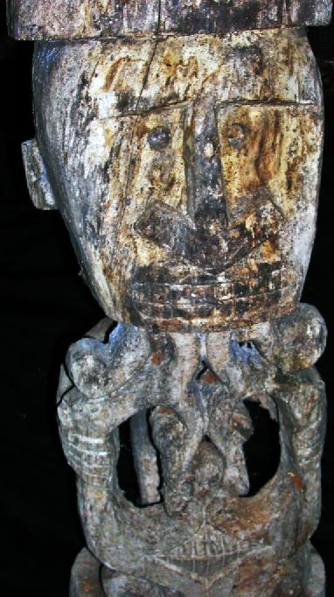 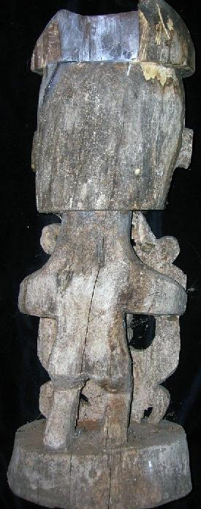 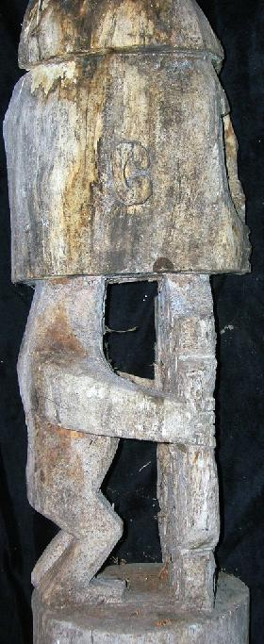

Biak cave, on the island of Biak, Indonesia.Location Lat 1° 0' 0S Long 136° 0' 0E Biak Island is located to the north of the New Guinea mainland. To the south is Geelvink Bay. 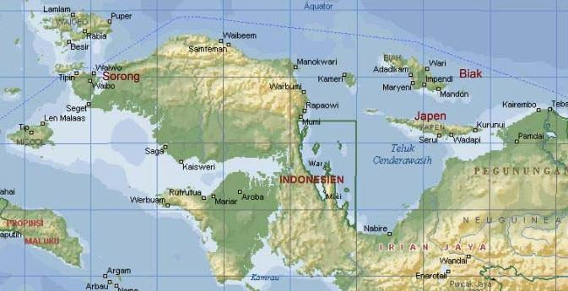

The unspoiled island of Biak is located in the Cendrawasih Bay of Papua (Irian Jaja), west of Papua new Guinea. Biak island itself is the biggest island in the Biak-Numfor regency with 1.898 square km area. The entire area of the regency is 3.130 square km which has a total 67 islands.

Each island is surrounded by a pristine white sandy beach with the breath-taking beauty of colourful shallow coral reefs and magnificent deeper coral gardens. The water is usually calm with visibility often excided 50m (150ft. Water temperature remains about 30°C all year round.

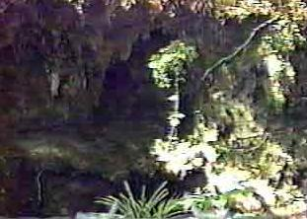

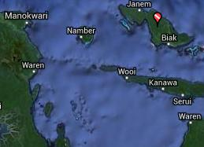

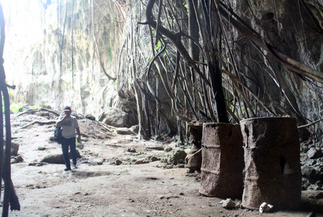

Sold by [primitifstuff](http://myworld.ebay.com/primitifstuff) ( [1804](http://feedback.ebay.com/ws/eBayISAPI.dll?ViewFeedback&userid=primitifstuff) )

### Delivery package 1 of 1

Estimated delivery Wednesday, Oct 14, 2015 - Saturday, Oct 17, 2015

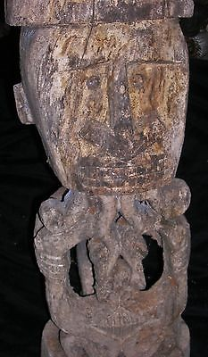

#### [BIAK CAVE FIGURE SKULL HOLE 26"](http://www.ebay.com/itm/221902128113)

|  |  |
| --- | --- |
| Item price | $89.99 |
| Quantity | 1 |
| Item number | 221902128113 |
| Shipping service | USPS Priority Mail |